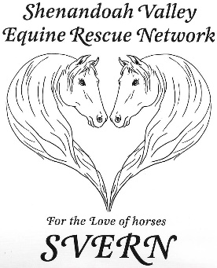

Name:____________________________ (must be at least 18 years old to apply)

Address:____________________________________________________

City:_________________ State:_____ Zip:______________

Phone (cell or primary):________________ Work:____________________

Do you currently have or have you ever owned a horse? __________

If you have not owned a horse, have you ever been responsible for the care of someone else’s horse(s)? Please give some detail if yes _____________________________________________

_____________________________________________________________________________

Do you still have your horses now? _____________________________

What is your horse background in general? ___________________________________________

______________________________________________________________________________

Name of horse you are applying for:________________________________________________

Is this horse for (check all that apply) ___ me to ride ___ someone else to ride ___ companion only

Other specifications: ____________________________________________________________

Will your horse be: ____ Living with me; ____ at a boarding facility

Name of farm (if not at adopter’s residence):______________________

Address:______________________________________________________________________

City:____________________________ State:________ Zip Code_____________

Contact number for facility:___________________

Who is you current equine vet?_____________________

Who is your current farrier? _______________________